(Class Set: Please Don’t Write on This!)
1984 Plans
• This famous commercial, shown during the Super Bowl in January, 1984, advertised the Macintosh computer. How could students use ideas, images or quotes from the novel to advertise something today, whether a product or a public service?
Find 1984 (John Hurt) Official Trailer:
42 Different Book Covers:
http://booksat.scarlettrugers.com/bookcoverdesign/george-orwells-42-different-covers-for-1984/

Warm-Up | Give students the following list of words from “1984”:
- Big Brother
- doublethink
- thoughtcrime
- Newspeak
- memory hole
- Orwellian
Students who have read the novel will recognize their provenance and should define them, as well as give a contemporary example of something that could be described similarly. Engage students who have not read the novel in a game in which they look at each word and suggest a definition based on what they know from the word alone and any connotations they bring to the parts of each word.
After students have shared their definitions, discuss the following questions, talk about whether students have heard any of these terms used in school, at home, among friends or in the media, and in what contexts.
For students who don’t know the source of these words, explain to them that they come from “1984,” a dystopian novel first published in 1949 that has loomed large in popular culture.
Lead them to contrast utopian fiction, which imagines an ideal world, with dystopian fiction, which imagines a nightmare world. Then explore these questions: Why are these terms and the concepts they name still part of our vocabulary? What does it say about contemporary society that we use terms from a dystopian novel to describe aspects of it? In what way have these words taken on new meanings over time with the advent of new technologies? What do these words suggest about us and about our uses of technology? How are they used as references to concerns over freedom and privacy?
You might use the 2003 New York Times article “If It’s ‘Orwellian,’ It’s Probably Not” to further explore Orwell’s language with students and this list of references to Orwell on various blogs as examples of how his ideas have pervaded our language. (Given that these articles are a few years old, you might conduct simple Web searches of the six terms to show students how often, and where, they have come up recently online.)
Ask: How have communication technologies — including Facebook, Twitter, cellphones, smartphones and Web cams — changed our culture? Is there such a thing as privacy in a world where such technologies are ubiquitous? To prompt student reaction, you might read aloud portions from the Mashable post “Hey, Teens: Your Parents Are Probably Checking Your Facebook.”
In the New York Times Magazine article “Little Brother Is Watching,” Walter Kirn compares Orwell’s vision of nefarious communication technologies in “1984” to the reality we face today
Little Brother Is Watching:
In George Orwell’s “1984,” that novel of totalitarian politics whose great mistake was to emphasize the villainy of society’s masters while playing down the mischief of the masses, the goal of communications technology was brutal and direct: to ensure the dominance of the state. The sinister “telescreens” placed in people’s homes spewed propaganda and conducted surveillance, keeping the population passive and the leadership firmly in control. In the face of constant monitoring, all people could do was sterilize their behavior, conceal their thoughts and carry on like model citizens.
This was, it turns out, a quaint scenario, grossly simplistic and deeply melodramatic. As the Internet proves every day, it isn’t some stern and monolithic Big Brother that we have to reckon with as we go about our daily lives, it’s a vast cohort of prankish Little Brothers equipped with devices that Orwell, writing 60 years ago, never dreamed of and who are loyal to no organized authority. The invasion of privacy — of others’ privacy but also our own, as we turn our lenses on ourselves in the quest for attention by any means — has been democratized.
For Tyler Clementi, the Rutgers University student who recently committed suicide after a live-stream video of an intimate encounter of his was played on the Web, Little Brother took the form of a prying roommate with a webcam. The snoop had no discernible agenda other than silly, juvenile troublemaking, which made his actions more disturbing in certain ways than the oppressive prying of a dictatorship. The roommate, it seems, was acting on impulse, at least initially, and his transgression couldn’t be anticipated, let alone defended against. Clementi, unlike Orwell’s Winston Smith, who hid from the telescreens whenever possible and understood that the price of personhood was ceaseless self-censorship and vigilance, had no way of knowing that the walls had eyes. Nor did his unseen observer anticipate the ultimate consequences of his intrusion.
In “1984,” the abolition of personal space was part of an overarching government policy, but nowadays it’s often nothing more than a side effect of wired high spirits. The era of the “viral video,” when footage of some absorbing slice of life can spread overnight around the globe, is bringing out the anarchist in all of us. Sometimes the results are welcome, benign, and the intruder does his subject a favor. Take the young man who taped his girlfriend shimmying in front of a TV attached to a Wii Fit video game. He shot the clip without her knowledge, apparently, and in no time Google and YouTube made her famous. She capitalized on her high profile by appearing on “The Tyra Banks Show.”
There are also times, of course, when Little Brother does a positive service to society by turning the tables on the state and watching the watchers. The other day a video emerged that seemed to show an Israeli soldier dancing in a mocking manner around a cowering Palestinian woman whom he appeared to have under his control. The viewer couldn’t help but be reminded of more shocking pictures from Abu Ghraib — scenes of torture that might never have come to light if Little Brother hadn’t been standing nearby. The irony is that these images, which caused a convulsion of national moral conscience, were taken — in some cases, at least — as photographic boasts or trophies. So giddy with power and numb to its abuses were the camera-wielding prison guards that they indicted themselves with their own antics.
In the postideological YouTube-topia that Orwell couldn’t have foreseen, information flows in all directions and does as it pleases, for better or for worse, serving no masters and obeying no party line. The telescreens, tiny, mobile and ubiquitous, at times seem to be working independently, for some mysterious purpose all their own. This morning, when I sat down to write, I was distracted by a story on my computer about a Google Street View camera that snapped pictures of a corpse lying on a bloody street in urban Brazil. I clicked on the link, unable to do otherwise, and up came the awful, disconcerting image. For a moment, I felt like a voyeur, spiritually dirtied by what I saw. A moment later I was checking the weather report and the status of my I.R.A.
Questions | For discussion and reading comprehension:
- What does Mr. Kirn mean when he says that the invasion of privacy has been “democratized”?
- How are today’s communication technologies and communicators different from those Orwell imagined in “1984”?
- Do you agree or disagree with Mr. Kirn that the actions of Tyler Clementi’s roommate are “more disturbing” than those of Orwell’s Big Brother?
- In what way, according to Mr. Kirn, can the actions of “Little Brother” benefit society?
- How has today’s technology blurred the lines between what’s public and what’s private?
- What does Mr. Kirn mean when he says modern technology contributes to the fragmentation of society?

Related resources:

RELATED RESOURCES

From The Learning Network
- Literary Pilgrimages: Exploring the Role of Place in Writers’ Lives and Works

- Lesson: Online and Off the Record

From NYTimes.com
- Times Topics: George Orwell
- Officials Push to Bolster Law on Wiretapping
- Why Orwell Endures

Around the Web
- Fast Company: How the Social Media and Big Brother are Hurting Your Job Chances
- Pedablogical: 6 News Stories to Connect to Orwell’s 1984
- Wired: Does the Technology of Orwell’s 1984 Really Exist?
Activity | Tell students they will build on the work Mr. Kirn begins in this piece by comparing Orwell’s vision in “1984” with contemporary life.
Explain that they will do this by drawing comparisons and contrasts on a number of fronts — character, setting, theme, jargon, technology — calling upon their own lived experience and current events as they do so. Ask them to be as specific as possible in the parallels they draw. Offer them this model to help them get started.
Tell students to pair up and use this “1984” vs. Today T-chart (PDF) to get started.
When they are finished, invite students to share and discuss their ideas as a class. Discuss how the novel and the real world are different, in terms of how technology is used, by whom (government vs. ordinary citizens) and in what contexts.
Next, tell pairs that they will collaborate on a treatment for a modern adaptation of “1984” (for print, film or stage), including contemporary technology, drawing on the comparisons they drew between the novel and contemporary life. (Alternatively, have students write their treatments independently.) Note that, guided by their own interpretations, they can hew closely to the original with minor updates or diverge in ways that point up how the novel contrasts with the real world today.
As they work, ask them to consider how to update the setting, characters, themes and technologies to reflect, and comment on, contemporary society. To brainstorm in preparation for writing, students might add a third column to their T-charts to developing ideas for how to represent in fiction the ways “1984” and the modern world compare and contrast.
For inspiration, show and discuss these reimaginings of “1984” — one a short film, the other a television commercial — as models.
To draw on the issues of modern life in authentic, informed ways, students might read up further on the intersections of technology, First Amendment freedoms and privacy, like the articles “How Privacy Vanishes Online” and “The Web Means the End of Forgetting.” They might also delve into wiretapping and other surveillance methods used by the government.
Treatments should include characters, setting, themes and plot summaries and should offer a clear rationale for updating the novel in whichever way they choose. When their ideas are generated, students then write and pitch their treatments to their classmates.

http://www.huffingtonpost.com/entry/teens-1984-george-orwell-trump_us_5892445ce4b070cf8b8060a7

High School Students Reading ‘1984’ See A Mirror, Not Science Fiction

They’re drawing the line from “doublethink” to “alternative facts.”

By Rebecca Klein
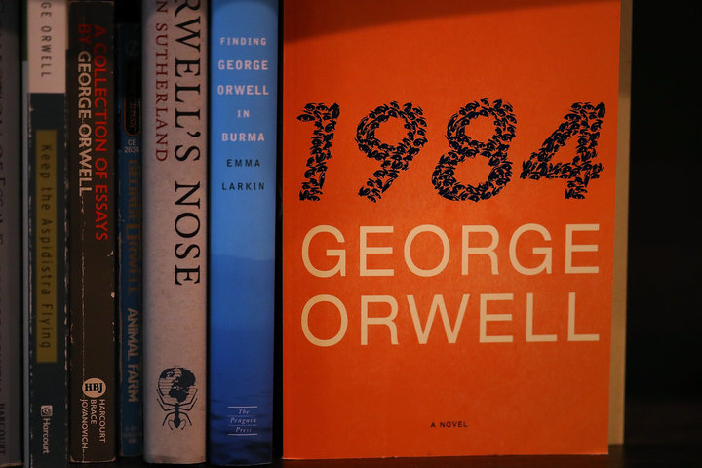
Justin Sullivan via Getty Images
1.7k

37
A dystopian world in which war is peace, freedom is slavery, and ignorance is strength doesn’t seem all that far-fetched to some students now studying George Orwell’s 1984.
Teachers who have assigned the classroom staple this year report that teenagers’ reactions to the text are different than in years past. All of sudden, they say, students are recognizing their own country in Orwell’s work of fiction.
“There’s less shock compared to years past,” said Michigan teacher Mike Becker. “A lot of students came up to me in the last few weeks and said stuff along the lines of ‘We’re living in 1984.’”
The novel 1984 ― which was published in 1949 ― describes a society in a state of never-ending war, where a repressive government led by “Big Brother” constantly surveils its citizens. The main character works for the Ministry of Truth, which actually oversees propaganda.
A lot of students came up to me in the last few weeks and said stuff along the lines of ‘We’re living in 1984.’ Mike Becker
Sales of 1984 skyrocketed in recent weeks after presidential adviser Kellyanne Conway described lies from White House Press Secretary Sean Spicer as “alternative facts.” Adult readers may have drawn a connection between Conway’s remarks and Big Brother’s manipulation of facts. Students appear to see that connection as well.
Becker has been teaching 1984 to his high school students for over six years. While the kids in his rural community have always compared the book’s plot to news events, the comparisons this year are heightened, he said. Students point to the real-world concepts of “fake news,” constant surveillance and media bias reflected in the text.
The teens, who come from a county that voted for President Donald Trump, don’t seem particularly bothered by the idea of government omnipresence, their teacher noted.
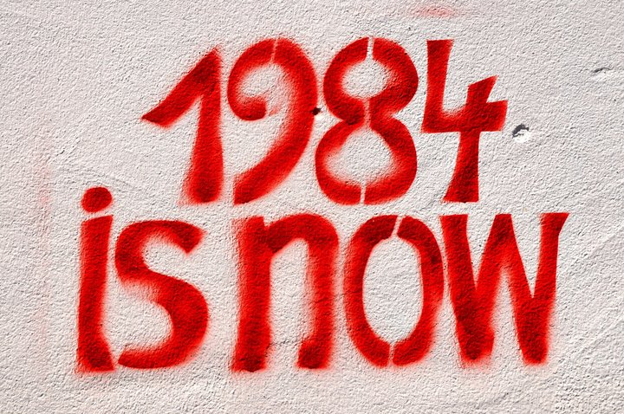
ullstein bild via Getty Images
“We self-monitor through things like social media, Snapchat, Instagram. We have these mini-cameras in our pocket,” Becker said. “That becomes so common for them, I think, on a daily level on that scale [that] the vast complexity scale of government surveillance doesn’t really frighten them as much.”
A few doors down from Becker, Aric Foster also taught 1984 this academic year. Even though his students read the book back in September, he said, one kid recently linked it to Conway’s “alternative facts” remark.
“One of them asked the other day, ‘Isn’t the whole discussion of alternative facts very similar to the 1984 idea of doublethink?’” said Foster. “The political climate is actually helping the children connect to the literature in ways that they haven’t done before.”
Across the country, in a suburb of Portland, Oregon, teacher William Milburn said the connections that his students are drawing between 1984 and the present are “inspiring but also heartbreaking at the same time.”
One of them asked the other day, ‘Isn’t the whole discussion of alternative facts very similar to the 1984 idea of doublethink?’ Aric Foster
Milburn teaches a diverse group of students in a progressive community. He thinks the book has given them a sense of urgency about the need to fight government oppression.
“They are looking at comments Trump has made about voter fraud, Spicer’s comment about the inauguration, Kellyanne Conway’s ‘alternative facts,’ and it just rings so similar to them about doublethink and an authoritarian government fluttering our news with information ― some true and false ― but all of it exhausting in the long run,” said Milburn.
He recalled one student saying “they’re worried about the EPA and other agencies being able to talk about climate change ― something we agree is a real thing and is fact and it’s possibly going to be censored.”
The current crop of high school students were born around the time of the 9/11 attacks and grew up during the U.S. wars in Afghanistan and Iraq, so they can also relate to the idea of perpetual war, Milburn said.
Overall, the teacher said, the book makes students concerned about the future. But they seem determined to fight back.
“A connection they’re also making to the story is about the importance of bravery,” said Milburn, “that it’s OK to question and challenge information that intuitively goes against our collective thoughts and beliefs.”
― ―
Rebecca Klein covers the challenges faced in school discipline, school segregation and the achievement gap in K-12 education. Tips? Email: Rebecca.Klein@huffingtonpos

The dystopia described in George Orwell’s nearly 70-year-old novel “1984” suddenly feels all too familiar. A world in which Big Brother (or maybe the National Security Agency) is always listening in, and high-tech devices can eavesdrop in people’s homes. (Hey, Alexa, what’s up?) A world of endless war, where fear and hate are drummed up against foreigners, and movies show boatloads of refugees dying at sea. A world in which the government insists that reality is not “something objective, external, existing in its own right” — but rather, “whatever the Party holds to be truth is truth.”
“1984” shot to No. 1 on Amazon’s best-seller list this week, after Kellyanne Conway, an adviser to President Trump, described demonstrable falsehoods told by the White House press secretary Sean Spicer — regarding the size of inaugural crowds — as “alternative facts.” It was a phrase chillingly reminiscent, for many readers, of the Ministry of Truth’s efforts in “1984” at “reality control.” To Big Brother and the Party, Orwell wrote, “the very existence of external reality was tacitly denied by their philosophy. The heresy of heresies was common sense.” Regardless of the facts, “Big Brother is omnipotent” and “the Party is infallible.”
As the novel’s hero, Winston Smith, sees it, the Party “told you to reject the evidence of your eyes and ears,” and he vows, early in the book, to defend “the obvious” and “the true”: “The solid world exists, its laws do not change. Stones are hard, water is wet, objects unsupported fall toward the earth’s center.” Freedom, he reminds himself, “is the freedom to say that two plus two make four,” even though the Party will force him to agree that “TWO AND TWO MAKE FIVE” — not unlike the way Mr. Spicer tried to insist that Mr. Trump’s inauguration crowd was “the largest audience to ever witness an inauguration,” despite data and photographs to the contrary.
In “1984,” Orwell created a harrowing picture of a dystopia named Oceania, where the government insists on defining its own reality and where propaganda permeates the lives of people too distracted by rubbishy tabloids (“containing almost nothing except sport, crime and astrology”) and sex-filled movies to care much about politics or history. News articles and books are rewritten by the Ministry of Truth and facts and dates grow blurry — the past is described as a benighted time that has given way to the Party’s efforts to make Oceania great again (never mind the evidence to the contrary, like grim living conditions and shortages of decent food and clothing).
Not surprisingly, “1984” has found a nervous readership in today’s “post-truth” era. It’s an era in which misinformation and fake news have proliferated on the web; Russia is flooding the West with propaganda to affect elections and sow doubts about the democratic process; poisonous tensions among ethnic and religious groups are fanned by right-wing demagogues; and reporters scramble to sort out a cascade of lies and falsehoods told by President Trump and his aides — from false accusations that journalists had invented a rift between him and the intelligence community (when he had compared the intelligence agencies to Nazis) to debunked claims that millions of unauthorized immigrants robbed him of a popular-vote majority.
Continue reading the main story

Related Coverage

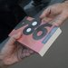

George Orwell’s ‘1984’ Is Suddenly a Best-Seller JAN. 25, 2017

ADVERTISEMENT
Continue reading the main story
Orwell had been thinking about the novel that would become “1984” as early as 1944, when he wrote a letter about Stalin and Hitler, and “the horrors of emotional nationalism and a tendency to disbelieve in the existence of objective truth because all the facts have to fit in with the words and prophecies of some infallible führer.”
Photo
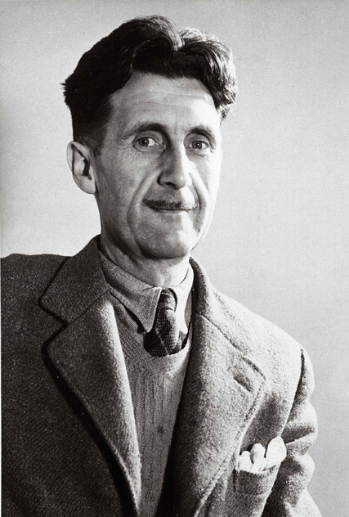
George Orwell in an undated image. His book “1984” has achieved new resonance. Credit Associated Press
Decades later, in the 1970s, “1984” would frequently be cited as holding a mirror to the Nixon administration’s duplicitous handling of the war in Vietnam and its linguistic, “Newspeak”-like contortions over Watergate (like the press secretary Ron Ziegler’s description of his earlier statements as “inoperative”).
In his 1944 letter, Orwell presciently argued that “there is no such thing as a history of our own times which could be universally accepted, and the exact sciences are endangered as soon as military necessity ceases to keep people up to the mark.” And in “1984,” the word “science” does not even exist: “the empirical method of thought, on which all the scientific achievements of the past were founded, is opposed to the most fundamental principles” of the Party.
This sort of marginalization in “1984” speaks to some of the very fears scientists have expressed in response to reports that the Trump administration is scrutinizing studies and data published by researchers at the Environmental Protection Agency while placing new work on “temporary hold.” Similar concerns about an Orwellian consolidation and centralization of government media control have been expressed over administration efforts “to curb the flow of information from several government agencies involved in environmental issues,” and the possibility, as Politico reported, that the new White House might also try to put its stamp on the Voice of America, the broadcasting arm that “has long pushed democratic ideals across the world.”

Newsletter Sign Up
Continue reading the main story

Book Review
Be the first to see reviews, news and features in The New York Times Book Review.
Top of Form
Bottom of Form
Top of Form
You agree to receive occasional updates and special offers for The New York Times's products and services.
Bottom of Form
- See Sample
- Privacy Policy
- Opt out or contact us anytime
Of course, all of these developments are being constantly updated, with regular flurries of news and denials and counterdenials — a confusing state of affairs that itself would not have surprised Orwell, since he knew the value of such confusion to those in power.
Another book, published two years after “1984,” also made Amazon’s list of top 100 best sellers this week: Hannah Arendt’s “The Origins of Totalitarianism” (1951). A kind of nonfiction bookend to “1984,” the hefty philosophical volume examines the factors that fueled the perfect storm of events leading to the rise of Hitler and Stalin and World War II — notably, the power that centralized storytelling can exert over anxious populations suffering from the dislocations of history, by offering scapegoats, easy fixes and simple cohesive narratives. If such narratives are riddled with lies, so much the better for those in power, who then succeed in redefining the daily reality inhabited by their subjects.
https://www.nytimes.com/2017/01/26/books/why-1984-is-a-2017-must-read.html

New York Times

Week In Review

Simpler Terms; If It's 'Orwellian,' It's Probably Not
By GEOFFREY NUNBERG JUNE 22, 2003
ON George Orwell's centenary -- he was born on June 25, 1903 -- the most telling sign of his influence is the words he left us with: not just ''thought police,'' ''doublethink'' and ''unperson,'' but also ''Orwellian'' itself, the most widely used adjective derived from the name of a modern writer.
In the press and on the Internet, it's more common than ''Kafkaesque,'' ''Hemingwayesque'' and ''Dickensian'' put together. It even noses out the rival political reproach ''Machiavellian,'' which had a 500-year head start.
Eponyms are always the narrowest sort of tribute, though. ''Orwellian'' doesn't have anything to do with Orwell as a socialist thinker, or for that matter, as a human being. People are always talking about Orwell's decency, but ''Orwellian decency'' would be an odd phrase indeed. And the adjective commemorates Orwell the writer only for three of his best known works: the novels ''Animal Farm'' and ''1984'' and the essay ''Politics and the English Language.''
''Orwellian'' reduces Orwell's palette to a single shade of noir. It brings to mind only sordid regimes of surveillance and thought control and the distortions of language that make them possible.
Orwell's views on language may outlive his political ideas. At least they seem to require no updating or apology, whereas his partisans feel the need to justify the continuing relevance of his politics. He wasn't the first writer to condemn political euphemisms. Edmund Burke was making the same points 150 years earlier about the language used by apologists for the French Revolution: ''Things are never called by their common names. Massacre is sometimes agitation, sometimes effervescence, sometimes excess.''
But Orwell is the writer most responsible for diffusing the modern view of political language as an active accomplice of tyranny. As he wrote in ''Politics and the English Language,'' ''Political language . . . is designed to make lies sound truthful and murder respectable, and to give an appearance of solidity to pure wind.''
That was an appealing notion to an age that had learned to be suspicious of ideologies, and critics on all sides have found it useful to cite ''Politics and the English Language'' in condemning the equivocations of their opponents.
Critics on the left hear Orwellian resonances in phrase like ''weapons of mass protection,'' for nonlethal arms, or in names like the Patriot Act or the Homeland Security Department's Operation Liberty Shield, which authorizes indefinite detention of asylum-seekers from certain nations. Critics on the right hear them in phrases like ''reproductive health services,'' ''Office of Equality Assurance'' and ''English Plus,'' for bilingual education.
And just about everyone discerned an Orwellian note in the name of the Pentagon's Total Information Awareness project, which was aimed at mining a vast centralized database of personal information for patterns that might reveal terrorist activities. (The name was changed last month to the Terrorist Information Awareness program, in an effort to reassure Americans who have nothing to hide.)
Which of those terms are deceptive packaging and which are merely effective branding is a matter of debate. But there's something troubling in the easy use of the label ''Orwellian,'' as if these phrases committed the same sorts of linguistic abuses that led to the gulags and the death camps.
The specters that ''Orwellian'' conjures aren't really the ones we have to worry about. Newspeak may have been a plausible invention in 1948, when totalitarian thought control still seemed an imminent possibility. But the collapse of Communism revealed the bankruptcy not just of the Stalinist social experiment, but of its linguistic experiments as well. After 75 years of incessant propaganda, ''socialist man'' turned out to be a cynic who didn't even believe the train schedules.
Political language is still something to be wary of, but it doesn't work as Orwell feared. In fact the modern language of control is more effective than Soviet Newspeak precisely because it's less bleak and intimidating.
Think of the way business has been re-engineering the language of ordinary interaction in the interest of creating ''high-performance corporate cultures.'' To a reanimated Winston Smith, there would be something wholly familiar in being told that he had to file an annual vision statement or that he should henceforth eliminate ''problems'' from his vocabulary in favor of ''issues.''
But the hero of ''1984'' would find the whole exercise much more convivial than the Two Minute Hate at the Ministry of Truth. And he'd be astonished that management allowed employees to post ''Dilbert'' strips on the walls of their cubicles.
For Orwell, the success of political jargon and euphemism required an uncritical or even unthinking audience: a ''reduced state of consciousness,'' as he put it, was ''favorable to political conformity.'' As things turned out, though, the political manipulation of language seems to thrive on the critical skepticism that Orwell encouraged.
In fact, there has never been an age that was so well-schooled in the perils of deceptive language or in decoding political and commercial messages, as seen in the official canonization of Orwell himself. Thanks to the schools, ''1984'' is probably the best-selling political novel of modern times (current Amazon sales rank: No. 93), and ''Politics and the English Language'' is the most widely read essay about the English language and very likely in it as well.
But as advertisers have known for a long time, no audience is easier to beguile than one that is smugly confident of its own sophistication. The word ''Orwellian'' contributes to that impression. Like ''propaganda,'' it implies an aesthetic judgment more than a moral one. Calling an expression Orwellian means not that it's deceptive but that it's crudely deceptive.
Today, the real damage isn't done by the euphemisms and circumlocutions that we're likely to describe as Orwellian. ''Ethnic cleansing,'' ''revenue enhancement,'' ''voluntary regulation,'' ''tree-density reduction,'' ''faith-based initiatives,'' ''extra affirmative action,'' ''single-payer plans'' -- these terms may be oblique, but at least they wear their obliquity on their sleeves.
Rather, the words that do the most political work are simple ones -- ''jobs and growth,'' ''family values'' and ''color-blind'' not to mention ''life'' and ''choice.'' But concrete words like these are the hardest ones to see through. They're opaque when you hold them up to the light.
Orwell knew that, of course. ''To see what is in front of one's nose needs a constant struggle'' -- not what you'd call an Orwellian sentiment, but very like the man.

